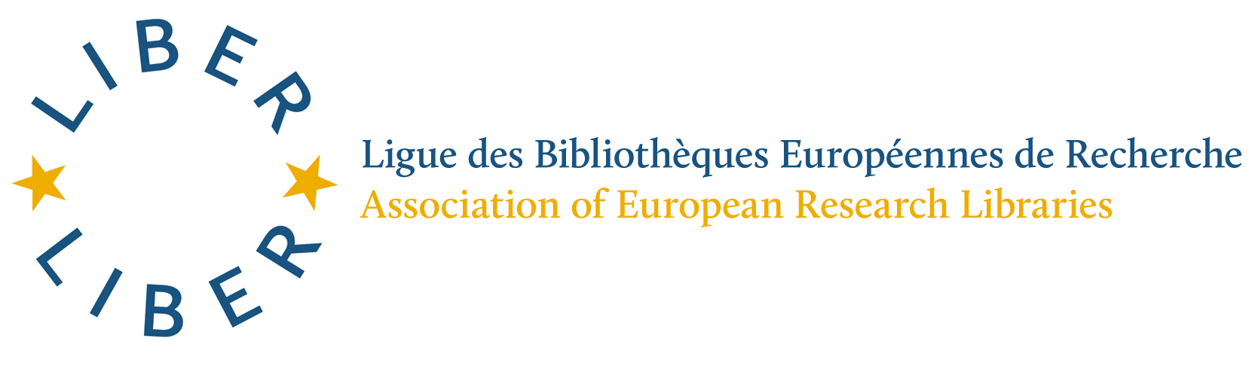

REPORT OF THE LIBER EXECUTIVE BOARD
2015-2016

I am pleased to give the Report of the LIBER Executive Board for the period June 2015 to June 2016.

executive board meetings
The Executive Board met on three occasions during the year: at the end of the 2015 Conference in London, UK; in CSUC, Barcelona, Catalonia, Spain, in October 2015; in the University of Patras, Greece, in February 2016; and the Board will have its fourth meeting of the year in June 2016 in the Paasitorni Conference and Congress Centre, Helsinki, Finland, at the beginning of Annual Conference week. LIBER’s Finance Committee held meetings in advance of all October, February and June Executive Committee meetings. LIBER’s Appointments Committee meets regularly at the October meeting and at other times as and when required. There is also a regular meeting of Steering Group Chairs, President, Vice-President and Executive Director at all Executive Board meetings. From 2014, the Executive Board has also instituted a ‘Discussion Slot’ prior to Executive Board meetings at which topics of strategic relevance to LIBER (e.g. strategic planning, copyright) are discussed by the Board.

executive board changes
At the Meeting of Participants in London on 25 June 2015, the following appointments and re-appointments were made. Drs Anja Smit, Utrecht University Library, The Netherlands, was appointed to the single vacancy on the Executive Board by a closed ballot, supervised by three Tellers (Mr Svend Larsen, Statsbiblioteket, Aarhus, Denmark; Ms Anna Rovira, Biblioteca de Catalunya, Barcelona, Catalonia, Spain; and Dr Ulrich Niederer, Lucerne University Library, Switzerland), held on the morning of Thursday 25 June 2015. Mr Lluis Anglada, CSUC, Barcelona, Catalonia, Spain, Dr Claudia Fabian, Bayerische Staatsbibliothek (BSB), Munich, Germany, and Mr Andris Vilks, National Library of Latvia, Riga, Latvia, were re-appointed to the Executive Board. Dr Ann Matheson, Secretary-General, was re-appointed by the Executive Board for the period 2015-2017.

In addition to the appointments to be made by LIBER Participants at the Meeting of Participants on 30 June 2016 in Helsinki, Finland, the Executive Board proposes to extend Dr Paul Ayris’ current period as an Adviser for the period 2016-2018, and to appoint Mr Julian Roche as an Adviser to the Board on the Leadership Programme for the period 2016-2018. (Art 8.3 of LIBER’s Rules and Regulations permits the Executive Board to appoint two Advisers to the Board: ‘The Board may name up to two persons to act as Advisers to the Board. Such Advisers shall have observer status.’)

executive board priorities
During the year 2015-2016, the Executive Board’s main priorities (which will be covered in more detail in reports presented at the Meeting of Participants in Helsinki) have been preparing the extension of the LIBER Strategy 2013-2015 to 2013-2017, and beginning the planning of the next Strategy covering the period 2018-2022; overseeing the work of the three Steering Committees (Scholarly Communication and Research Infrastructures; Reshaping the Research Library; and Advocacy and Communications), and their Working Groups, with two new Groups (Working Group on Open Access, attached to the Advocacy and Communications Steering Committee; and Working Group on Metrics, attached to the Steering Committee on Scholarly Communication and Research Infrastructures) created during the year; EU projects to assist LIBER Libraries; advocacy on topics of relevance to LIBER Libraries, e.g. copyright reform, text and data mining, etc.; organising the Annual Conference; and maintaining an effective Office for LIBER Libraries in The Hague. In addition, the Digital Cultural Heritage Forum and Architecture Forum have advanced their programmes during the year and will present their reports at the June 2016 Meeting of Participants. A report on LIBER Quarterly will also be sent to LIBER Participants in the May 2016 LIBER Mailing. The Conference Programme Committee, led by LIBER Vice-President, Jeannette Frey, as Chair, prepared the 45th LIBER Annual Conference, which will take place in Helsinki, Finland, in June 2016.

staffing
There have been fewer changes in staffing during the year 2015-2016. Dr Dan North left the LIBER Office in July 2015. Ms Friedel Grant, Communications Officer, returned from maternity leave in September 2015. In line with Dutch law, on her return Ms Grant worked two days a week until December 2015 and will work three days a week during 2016. In August 2015, Ms Helen Frew was appointed Advocacy Officer on a one-year contract to August 2016; and in October 2015, Ms Bueno de la Fuente was appointed EU Projects Officer on a one-year contract to October 2016. Ms Suzanne Reid’s position as Office Manager was made permanent with effect from May 2016.

The LIBER Office presently comprises: Ms Susan Reilly, Executive Director; Ms Suzanne Castro Reid, Office Manager (80% FTE; 60% LIBER Office; 20% EU Projects); Ms Friedel Grant, Communications Officer (60% FTE: 20% LIBER Office; 40% EU Projects); Ms Melanie Imming, EU Projects Manager (80% FTE; 70% EU Projects; 10% LIBER Office); Mr Pablo de Castro, Open Access Project Officer (100% FTE: EU Projects); Ms Hege van Dijke, Communications & Events Officer (100% FTE: EU Projects); Ms Gema Bueno de la Fuente, EU Project Officer (FTE 100%: EU Projects); and Ms Helen Frew, Advocacy Officer (FTE 80%: 10% LIBER Office: 70% EU Projects).

The Appointments Committee (President, Vice-President, Secretary-General and Treasurer, with the Executive Director in attendance) met in Barcelona in October 2015, and reviewed staff contracts, a staffing policy document and Office accommodation needs. The Appointments Committee meets regularly at the October meeting annually and on other occasions if required.

liber participation (i.e. membership)
The current number of LIBER Libraries at May 2016 stands at a total of 419 Participants (Institution: 387; Organisation: 17; Associate: 9; and Individual: 6).

sponsorship
The Board is extremely grateful for the invaluable support of LIBER’s Gold and Silver Sponsors in 2015-2016. The Gold Sponsors in 2015-2016 are: Springer (until 31 December 2015), Ex Libris, beslist.nl and Ebsco (from 1 January 2016); and the Silver Sponsors are: Tind Technologies, Royal Society of Chemistry, Ebsco (up to 31 December 2015), and ProQuest (up to 31 December 2015). The Board also very much welcomes the continuing support of OCLC in sponsoring the LIBER Award for Library Innovation in 2016. OCLC first sponsored this Award in 2015. The contribution of all Sponsors in assisting LIBER’s work is greatly appreciated.

liber annual conference fund 2016
There were twenty-two applications to the Fund in 2016, and ten grants were made. Of the total applications, fourteen were accompanied by paper or poster submissions, from which seven grants were made, and eight were received without submissions, from which three grants were made. The successful awardees in 2016 are:

Bojan Macan, Rudjer Boskovic Institute, Croatia
Panos Georgiou, Library & Information Center, University of Patras, Greece
Nicoleta-Roxana Dinu, National Library of Romania, Romania
Vasilije Milnovic, Svetozar Markovic University Library, Serbia
Cem Özel, Sabanci University, Turkey
Sina Mater, Koç University Suna Kıraç Library, Turkey
Ismet Ovčina, National and University Library of Bosnia & Herzogovina
Yeznik Mirzoyan, Sarkis and Marie Izmirlian Library, Armenia
Radostina Todorova, New Bulgarian University, Bulgaria
Tatijana Petrić, National and University Library Zagreb, Croatia

liber annual conferences
The 2016 45th LIBER Annual Conference is being held in the Paasitorni Congress and Conference Centre, Helsinki, Finland, hosted by the National Library of Finland, Helsinki University Library and the Finnish Research Library Association, and on the theme ‘Libraries Opening Paths to Knowledge’. The Conference dates are 29 June to 1 July, with the Pre-Conference on 27 and 28 June and the Conference Excursion on 2 July 2016. The 46th LIBER Annual Conference will be held in the Congress Centre, University of Patras, Greece, from 3 to 7 July 2017, hosted by the Library and Information Centre, University of Patras. An invitation to LIBER delegates will be given by the University of Patras at the Meeting of Participants on Thursday 30 June 2016.

national library of the netherlands
The Executive Board warmly thanks the National Library of the Netherlands, and its Director-General, Dr Lily Knibbler, for their continuing support and assistance to LIBER in numerous ways.

Ann Matheson
Secretary-General

May 2016

⎯⎯⎯⎯⎯⎯⎯⎯⎯⎯⎯⎯⎯⎯⎯⎯⎯⎯⎯⎯⎯⎯⎯⎯⎯⎯⎯⎯⎯⎯⎯⎯⎯⎯⎯⎯⎯⎯⎯⎯⎯⎯⎯⎯⎯
Stichting LIBER Koninklijke Bibliotheek, P.O. Box 90407, 2509 LK The Hague, The Netherlands. Chamber of Commerce: 27334736

